Retail Inventory Program Documentation
1. Purpose
This database is designed to manage products in a retail store. It keeps track of categories (like Mobile, Laptop, TV) and the products that belong to them. It ensures data accuracy, fast searching, and smooth integration with a Python application.
2. Structure
There are two main tables:
- Categories: Defines product groups (e.g., Mobile, Laptop).
- Products: Stores details about each product (brand, name, price, quantity, supplier, status).
Relationship:
- One category can have many products.
- Each product belongs to exactly one category.
- This is enforced by a foreign key.
3. Tables
Categories Table
- category_id: Unique ID (auto-generated).
- category_name: Name of the category (must be unique).
Products Table
- product_id: Unique ID (auto-generated).
- category_id: Links to the category table.
- brand: Manufacturer name.
- product_name: Product name.
- price: Cost (stored as FLOAT here).
- quantity: Number of items in stock.
- supplier: Supplier name.
- status: Stock status (default: "Stock sufficient").

4. Index
An index is created on product_name to make searches faster.
This helps when searching products by name using queries like LIKE '%phone%'.

5. Stored Procedure
A stored procedure (add_product_proc) is used to add new products.
It ensures:
- Products are inserted consistently.
- Default status is always set to "Stock sufficient".
- The Python app calls this procedure instead of writing raw SQL.

6. Trigger (Automatic Stock Monitoring)
A trigger runs whenever a product’s quantity is updated:
- If quantity < 5 → status becomes "Low stock: Only X left".
- Otherwise → status is "Stock sufficient".
This ensures the stock status is always correct, no matter how the update happens.

7. Initial Data
The system starts with categories like:
- Mobile, Laptop, TV, Accessories, Headphones, Camera.

8. Application Features
The Python app connected to this database can:
- Add Product → Calls the stored procedure.
- View Products → Joins categories and products.
- Search Product → Uses the index for fast lookup.
- Update Product → Trigger updates stock status automatically.
- Delete Product → Removes product by ID.

Flow of Program:

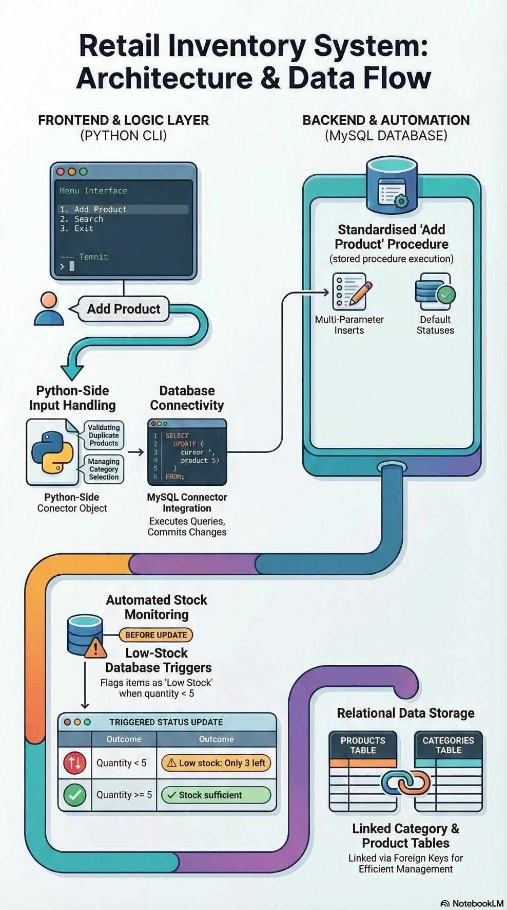

Database Desgin:
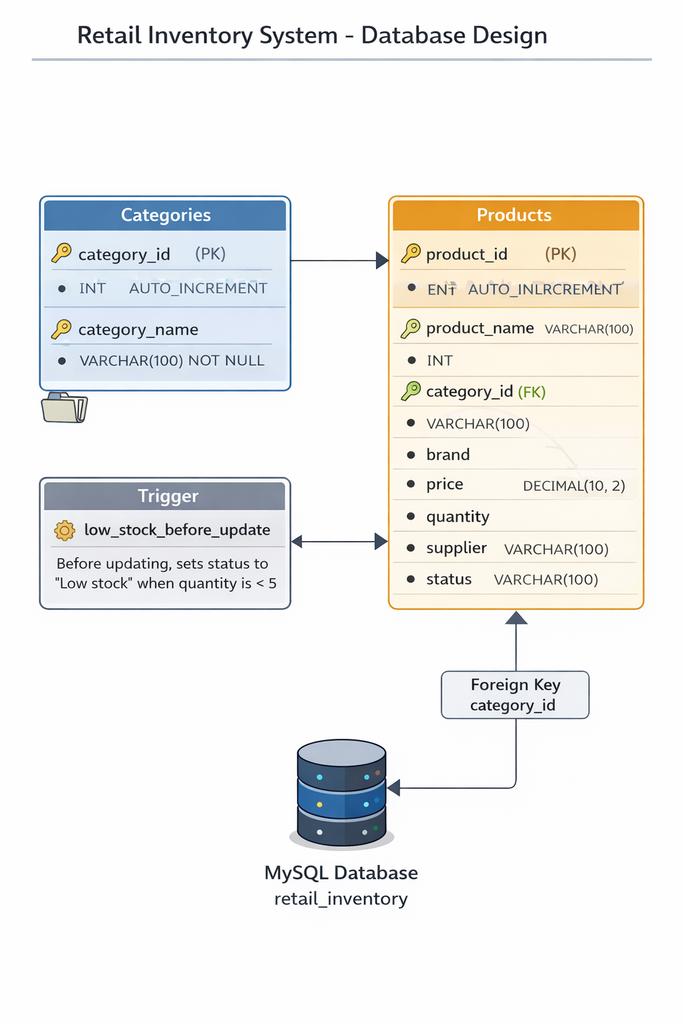

Technologies Used:
1. AI Tools
- ChatGPT – Used for generating code suggestions, debugging errors, and understanding programming concepts during development.
- Microsoft Copilot – Assisted in improving code efficiency and providing coding suggestions while writing the program.
- Google NotebookLM – Used for analysing documents, organizing notes, and assisting with project understanding.
2. Programming Languages and Development Tools
- Python – Used to implement the application logic of the Retail Inventory System.
- Visual Studio Code – Used as the development environment for writing and running Python code.
- Oracle MySQL Workbench – Used to create and manage the database, tables, and SQL queries.
- MySQL – Used as the backend database to store product and category information.

